Autonomous Vehicles

Assignment 02

PhD. Patricia McManus

Compute Vision Artificial Intel-13788

(ITAI-1388)

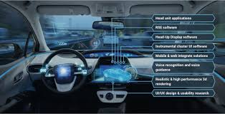

Student : Enrique Quintero

Autonomous Vehicles

What is autonomous vehicle, or a driverless vehicle? The common answer is one that is able to operate itself and perform necessary functions without any human intervention, through ability to sense its surroundings. Many times when we speak about autonomous vehicles many people thinking in cars, but autonomous is any vehicle with passengers or without passengers. For example, drons, vaccums, Agricol machines,submarines.

An autonomous vehicle utilises a fully automated driving system in order to allow the vehicle to respond to external conditions that a human driver would manage.

**Autonomous car topology**

**How it works for ?**

**LIDAR (Light Detection and Ranging):** Use lasers to measure distances to objects and create a three-dimensional map of the environment. This is essential for accurate obstacle detection and creating detailed maps. this technique is used in airplanes.

**Cameras:**

New Technique Improves AI Ability to Map 3D Space With 2D Cameras

**They capture 2D images of the environment:** Cameras are essential for detecting traffic signs, road markings, pedestrians and other vehicles. They can be monocular or stereoscopic to improve depth perception.

**IMU (Inertial Measurement Unit**): Integrates and analyzes information from all sensors in real time.

**Vehicle Control Systems:** Based on sensor fusion algorithms, machine learning, and image processing to make driving decisions.

**Vehicle Control Systems**: Include electronic controllers that manage the vehicle. Short-Range and Long-Range Radar.

**Navigation system:** The most crucial component of an autonomous vehicle is its navigation system. Additionally, the navigation system can see changes in road conditions and adjust the vehicle's speed accordingly.

**Obstacle detection:** Another critical component of an autonomous vehicle is its obstacle detection and avoidance system. This system uses sensors, cameras, and radar to identify and detect obstacles in the vehicle's path. Once an object is detected, the system can take appropriate evasive action to avoid it. Obstacle detection must work extremely fast to ensure the vehicle's and its passengers' safety.

**Communication system:** In addition to navigation and obstacle detection systems, autonomous vehicles also have a variety of other functional components. These include a communication system, which allows the car to communicate with other cars;

These components work together to allow the vehicle to drive safely and efficiently.

**Behind of Self-Driving Cars Convolutional Neural Networks (CNN)** Is one of most technologically used on autonomous cars.

**How do self-driving cars work?**

The first self-driving car was invented in 1989, it was the **Automatic Land Vehicle in Neural Network** (ALVINN). It used neural networks to detect lines, segment the environment, navigate itself, and drive. It worked well, but it was limited by slow processing powers and insufficient data.

With today’s high-performance graphics cards, processors, and huge amounts of data, self-driving is more powerful than ever. If it becomes mainstream, it will reduce traffic congestion and increase road safety.

Self-driving cars are autonomous decision-making systems. They can process streams of data from different sensors such as cameras, LiDAR, RADAR, GPS, or inertia sensors. This data is then modeled using deep learning algorithms, which then make decisions relevant to the environment the car is in.

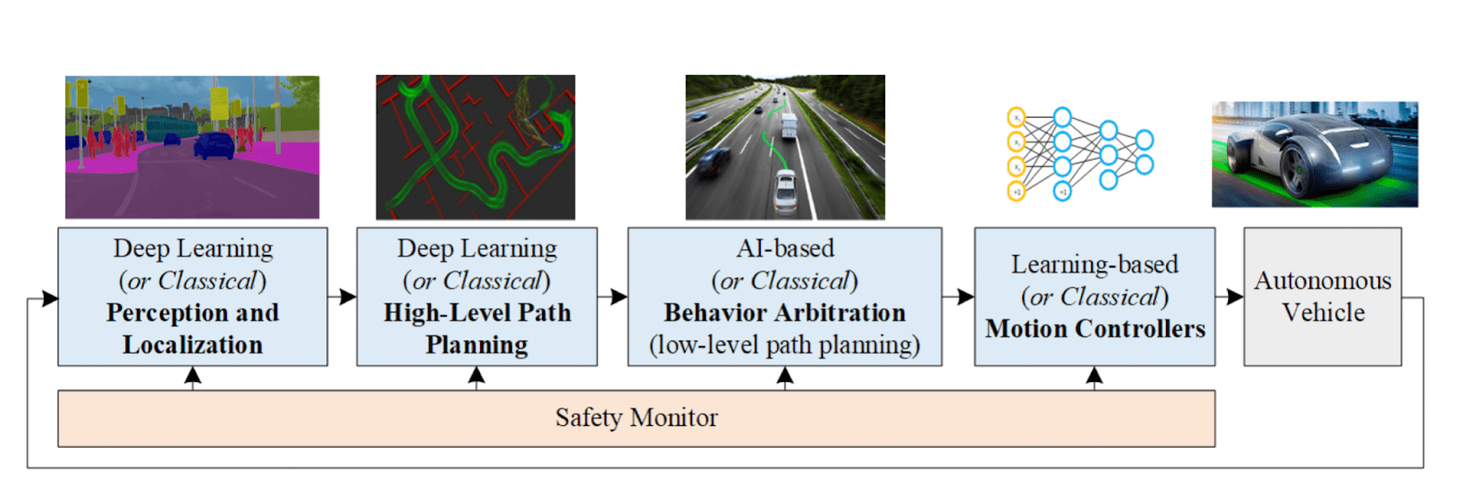

<https://neptune.ai/blog/self-driving-cars-with-convolutional-neural-networks-cnn>

**Advantages:  
Benefits of autonomous driving**

Autonomous driving in itself has both advantages and disadvantages. That's why opinions on the subject vary widely. For example, autonomous driving cars have **great potential,** but also pose various challenges.

**1. More Safety**

Accidents are often caused by driver fatigue, lack of attention or **incorrect behavior.** This means that almost 99% of all accidents are due to human error. With the elimination of the driver as a source of error and increasing sophistication of systems (sensors, cameras, and AI system), driving can be made **more efficient**

**2. More Time and Comfort**

Depending on the **level of the autonomous vehicle,** drivers can sit back and relax, take short breaks and **devote their time to other things.** In the best case, with a level 5 vehicle, you are just a passenger, while the means of transport reliably takes you to your destination.

**3. More Efficiency in Traffic**

Autonomous vehicles are able to communicate and coordinate with each other**(Car2x communication)**. They can thus **improve traffic flow**and increase road capacity.

This reduces annoying and time-consuming traffic jams, allows **shorter routes**to be taken, and makes driving **more efficient and energy-saving** overall. This also offers major advantages in logistics.

**4. Parking Spaces**

With autonomous vehicles, **fewer parking spaces** are needed if the car lets the passenger off and continues on to the next destination. However, if a parking space is still needed, the user is spared the long search for a free space, because the car can independently look for a parking space and then transmit the position data.

**Reflection**

Autonomous vehicles—on the road, in the air, or over the water—are expected to disrupt business processes, operating costs, and economic models. Logistics and supply chain operations will be deeply affected, as will the relationship between service providers and customers.

If autonomous vehicles are to come into wide use, an array of complementary services and technologies will be needed to support them. These autonomy “ecosystems” will echo in many ways the businesses, technologies, jobs, and services that developed following the invention and then the widespread use of automobiles, trucks and airplanes.

Finally, many industries will be positively transformed, for example freight transport, typical shipping or heavy industries such as mining or construction.

Delivery

freight transport

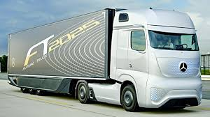

Heavy industries



References

<https://en.wikipedia.org/wiki/Lidar>

<https://ece.ncsu.edu/2024/new-technique-improves-ai-ability-to-map-3d-space-with-2d-cameras/>

<https://neptune.ai/blog/self-driving-cars-with-convolutional-neural-networks-cnn>

<https://www.swarco.com/mobility-future/autonomous-driving/autonomous-driving-pros-cons>

LIDAR

<https://www.youtube.com/watch?v=H2-Yp30TGk4>